The fan assembly is located on the right hand side rear inner wing, its all accessible via the boot, but you have to remove the inner panel in order to get at the fan and filter.
First remove the false floor, then remove the tool tray below the false floor, there are 6 self expanding clips (3 on each side), in order to remove them prise out the centre with a flat ended screwdriver.
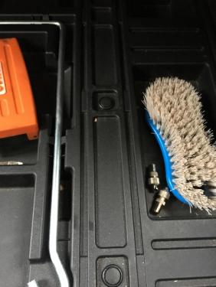

lift the tool tray out, this will reveal another 3 of these clips that hold the carpet into the rear of the boot, these need to be removed as well
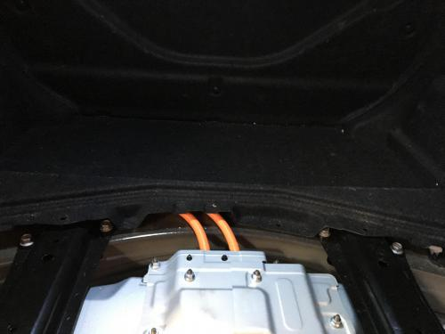

the looking at the right side boot trim there are two load restraints that need to be removed, they are held in place with a 10mm bolt, this is hidden. in order to get at the bolt you need to prise the plastic cover away with a screwdriver
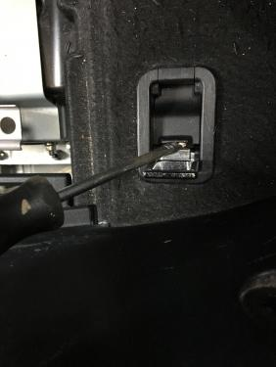

Undo the 10 mm bolts and remove the restraints.
Looking at the right hand inner boot panel there are 3 trim clips that hold the panel to the car, they are 'spined' and need to be prised out. you can see the 3 holes in the picture.
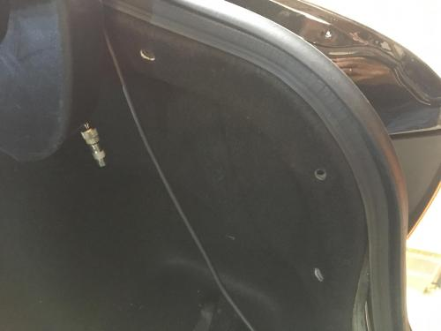

With these out the last piece to be removes is the plastic threshold trim, this has another 3 of the spined clips that are used on the inner trim panel. Once they are removed the panel requires a sharp pull as there are 6 clips attached to the threshold trim that need to be released from the body.
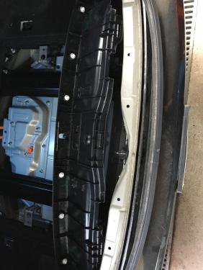
Now you can pull/bend
the inner trim back to reveal the fan assembly and trunking for the air duct
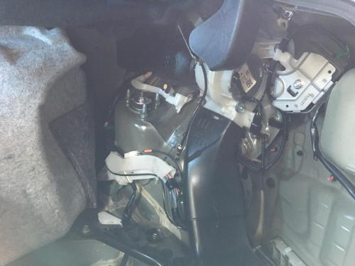
the black trunking that runs from the fan to the hybrid Battery is held in place with 2 self expanding clips, again prise the centre pin out and the pull the clip out in order to remove the trunking.
The motor is held in place with 2x10mm bolts and 1x10mm nut
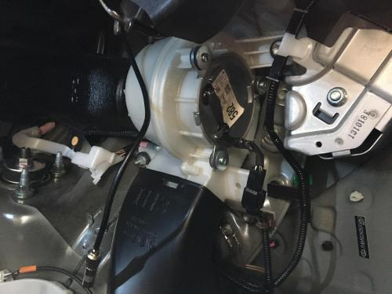
There is also a multiplug that will need to be disconnected in order to remove the fan assembly from the car.
Once removed you then have access to the trunking that has the filter in it
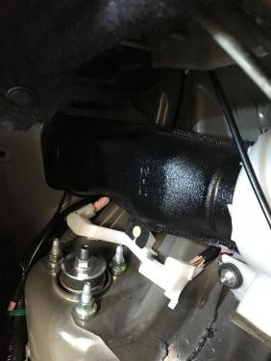
With the motor out of the way the trunking is held in place by a tag at the bottom of the trunking that locates on a plastic pin, a sharp pull will see it come free. and this is what you may find!!
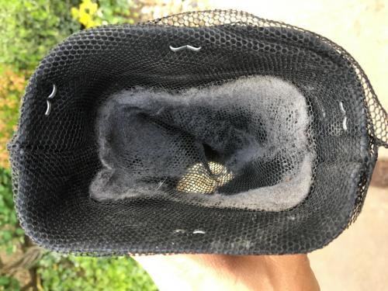
Full of fluff and crud, with a vacuum cleaner give this a good clean, then clean the motor.
The vanes will be fill of dirt and crud as well, with an airline blow this all out (watch your eyes as there will be a lot of dust)
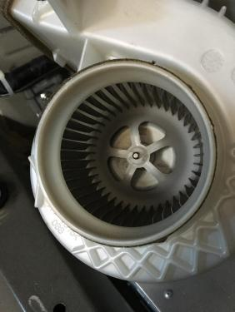
Cleaned out
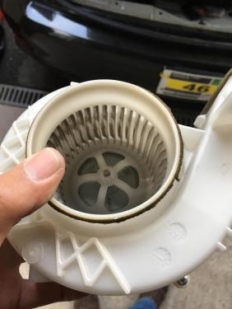
Putting it all back together is the reverse this, however when reconnecting the fan motor please make sure the connectors go back together with a solid 'CLICK' if they don't and the pins haven't made good connection you will get a 'check hybrid' error message, once the fan motor and trunking is in place and before I have built up the interior trim I normally turn the ignition on so as to check that everything is in order.

Take the pipe out with the yellow sign. On the other end you will find the boot. (Red sign) If you look good at your first picture you will see the bootfilter (Green sign)



